Contents

EVM (Ethereum Virtual Machine) 2

1. Introduction of EVM 2

2. So how do you make a program that execute on all of the computers? 2

3. Why do we have EVM in the middle on the process? 3

4. How does EVM execute instructions? 3

# Nodes

## What kind of information does Nodes exactly hold in order to make ETH possible?

In Bitcoin nodes have full version of blockchain so they have all the information and in the blockchain they have all the transactions that have happened.

In ETH they have smart contracts, blockchain now has all transactions and transactions look a bit different from bitcoin but still you have all the records of transactions in the blockchain. Then you have the codes for all smart contracts, mostly byte codes.

And then you have states of all Smart Contracts.

s1 = states

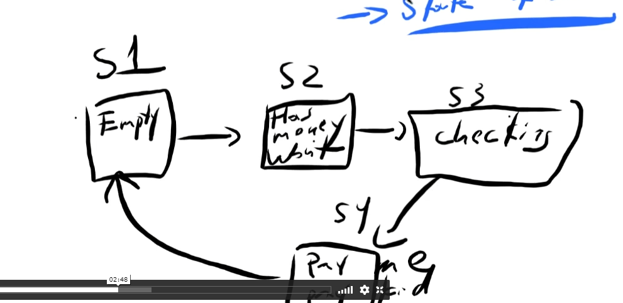

# UTXO vs Account Model

When your wallet finds the sum of your money, it will search all the UTXO (Unspent Transactions) that you can spend. It is unlike bank account where it shows you balance, here in wallet it shows you only UTXO and then you add altogether and gets you wallet.

In ETH you have a balance, in ETH blockchain will store all of your transactions but at the same time you do not have UTXO models, each transaction updates accounts.

For example, If I have a 5 ETH on my balance and if was sending to someone, the transaction would now just update my account balance. So if I send 1 ETH to somebody, my balance of ETH would now be 4 ETH. It just switches numbers.